**Visvesvaraya Technological University, Belagavi– 590018**

**DBMS MINI PROJECT REPORT**

**ON**

**“BLOOD BANK MANAGEMENT SYSTEM”**

***Submitted by***

**MAYOORI P 4JK20IS028**

**KAVYA 4JK20IS022**

**Under the Guidance of**

**Mrs. Sivapuram Jayasri Mrs. Archana Priyadarshini Rao**

**(Asst Professor, Department of ISE) (Asst Professor, Department of ISE)**



**DEPARTMENT OF INFORMATION SCIENCE AND ENGINEERING**

1. **J. INSTITUTE OF ENGINEERING AND TECHNOLGY**

**Kottara Chowki Mangalore, 575006 – Karnataka**

1. **– 2023**

**A.J. INSTITUTE OF ENGINEERING AND TECHNOLOGY**

**Kottara Chowki, Mangalore – 575006**

**DEPARTMENT OF INFORMATION SCIENCE AND ENGINEERING**



***CERTIFICATE***

*This is to certify that the Mini project entitled* ***“Blood Bank Management System”***

*Is a bonafide work carried out by*

***Mayoori P 4JK20IS028***

***Kavya 4JK20IS022***

*Students of fifth semester B.E. Information Science & Engineering, and submitted as a part of the course DBMS Laboratory with Mini Project (18CSL58), during the academic year2022-2023.*

***----------------------------- --------------------------------- ----------------------------***

**Mrs. Sivapuram Jayasri Mrs. Archana Priyadarshini Rao Dr. Suresha D**

**(Asst Professor, ISE) (Asst Professor, ISE) (Head of the department)**

**Name of the Examiners Signature with date**

**1……………………………… 1.…………………………..**

**2……………………………… 2. …………………………..**

**ABSTRACT**

This project aims to develop a Blood Bank Management System. A Blood Bank Management

System can be used in any clinic, hospital, labs or any emergency situation which requires

blood units for survival. Our system can be used to find required type of blood in emergency

situations from either blood bank or even blood donors.

The blood bank receives large number of blood from donors. The information about the blood donor needs to be updated. Whenever the information about the donor is required it is difficult for the blood bank authority’s people to search the records manually. To solve this problem, we proposed a blood donation management system in which electronic information about the in the blood bank is created for the donor. The main objective is to automate the complete process of the blood donation in the blood bank. At present online databases are available, they did not offer direct link between the donor and the recipient. This project aims to develop a Blood Bank Management System. A Blood Bank Management System can be used in any clinic, hospital, labs or any emergency situation which requires blood units for survival.

Our system can be used to find required type of blood in emergency situations from either blood bank or even blood donors.

**ACKNOWLEDGEMENT**

We dedicate this page to acknowledge and thank those responsible for the shaping of the project. Without their guidance and help, the experience while constructing the dissertation would not have been so smooth and efficient.

We sincerely thank the **Management of A. J. Institute of Engineering and Technology,**

(A Unit of Laxmi Memorial Education Trust®) for their continuous support.

We are extremely thankful to our **Principal, Dr Shantharama Rai C,** for his support and encouragement.

We owe our profound gratitude to **Dr Suresha D, Head of the Department**, Information Science and Engineering, whose kind consent and guidance helped us to complete this work successfully.

We sincerely thank **Mrs Sivapuram Jayasri, Assistant Professor** and **Mrs Archana Priyadarshini Rao, Assistant Professor** Science and Engineering, for their guidance and valuable suggestions which helped us to fulfill the experiments prescribed by the university.

We would like to thank all our Information Science and Engineering staff members who have always been with us extending their support, precious suggestions, guidance and encouragement through the project.

We also like to extend thanks to our friends and family members for their continuous support.

**CONTENTS**

**CHAPTER: TITLE PAGENO.**

|  |  |  |  |
| --- | --- | --- | --- |
| 1. | Introduction…………………………………………………………… | 01 |  |
|  | * 1. Problem definition………………………………………. | 01 |  |
|  | 1.2 Scope of Project…………………………………………. | 02 |  |
| 2. | Software Requirement Specification…………………………………. | 03 |  |
|  | 2.1FunctionalRequirements ………………………………… | 03 |  |
|  | 2.2HardwareRequirements…………………………………. | 03 |  |
|  | 2.3 Software Requirements……………………………………  2.4 Languages Used…………………………………………….  2.5 Visual Studio IDE.………………………………………….  2.6 XAMPP……….…………………………………………….  2.7 User Interface……………………………………………… | 03  03  04  04  04 |  |
|  |  |  |  |
| 3. | System Design………………………………………………………… | 06 |  |
|  | 3.1 ER Model ………………………………………………… | 06 |  |
|  | 3.2 Schema Diagram …………………………………………… | 07 |  |
|  | 3.3 Table Description………………………………………… | 08 |  |
| 4. | Implementation……………………………………………………… | 12 |  |
|  | 4.1 Details of the Language……………………………………. | 12 |  |
| 5. | Screenshots……………………………………………………………. | 15 |  |
|  | 5.1 Screenshots of table created………………………………… | 15 |  |
|  | 5.2 Screenshots of Front End…………………………………… | 18 |  |
| 6. | Conclusion and Future Work………………………………………….. | 30 |  |
| 7 | 6.1 Conclusion ……………………………………………………  6.2 Future Work……………………………………………………  Reference……………………………………………………………… | 30  30  31 |  |

**LIST OF FIGURES**

|  |  |  |
| --- | --- | --- |
| **Figure No.** | **Title** | **Page No.** |
| Figure3.1 | ER Diagram……………………………………..…… | 06 |
| Figure3.2 | Schema Diagram…………………………………….. | 07 |
| Figure5.1.1 | Data base table…………………………………………. | 15 |
| Figure5.1.2 | Admins table……………………………….………… | 15 |
| Figure5.1.3 | Blood donate table……………………………………. | 15 |
| Figure5.1.4 | Blood info table.……………………………………… | 16 |
| Figure5.1.5 | Blood request table……………………………….….. | 16 |
| Figure5.1.6 | Hospital table………..………………………………. | 16 |
| Figure5.1.7 | Campaigns table…… ………………………………. | 17 |
| Figure5.1.8 | Donors table ………………………………............... | 17 |
| Figure5.1.9 | Receivers table ……………..………………............. | 17 |
| Figure5.11 | Front End of Homepage…….……………………... | 18 |
| Figure5.12 | Front End of Hospital Register page………………… | 18 |
| Figure5.13 | Front End of User Register page…………………….. | 19 |
| Figure5.14 | Front End of Admin Register page…….…………… | 19 |
| Figure5.15 | Front End of Hospital login page…………………… | 20 |
| Figure5.16 | Front End of User login page……………..………… | 20 |
| Figure5.17 | Front End of Admin login page…………………….. | 21 |
| Figure5.18 | Front End of About Us and Contact Us page………. | 21 |
| Figure5.19 | Front End of Hospital Dashboard page…………….. | 22 |
| Figure5.20 | Front End of Hospital Account Details page….….. | 22 |
| Figure5.21 | Front End of Hospital Entry Stock page………….. | 23 |
| Figure5.22 | Front End of Hospital Blood Request Approval page | 23 |
| Figure5.23 | Front End of Hospital Blood Request page………….. | 24 |
| Figure5.24 | Front End of Hospital Blood request Status page..….. | 24 |
| Figure5.25 | Front End of User Dashboard page………………….. | 25 |
| Figure5.26 | Front End of User Account Details page….………… | 25 |
| Figure5.27 | Front End of Available Blood page….……………… | 26 |
| Figure5.28 | Front End of Donor Registration page….…….…… | 26 |
| Figure5.29 | Front End of Admin Dashboard page….…………… | 27 |
| Figure5.30 | Front End of Available Blood page….……………… | 27 |
| Figure5.31 | Front End of Campaign Register page….…………… | 28 |
| Figure5.32 | Front End of Registered campaigns page….………… | 28 |
| Figure5.33 | Front End of Available Blood stock page….………. | 29 |

**CHAPTER 1**

**INTRODUCTION**

This has been designed to override the problems prevailing in the practicing manual system. This software is supported to eliminate and, in some cases, reduce the hardships faced by this existing system

The application is reduced as much as possible to avoid errors while entering the data. It also provides error message while entering invalid data. No formal knowledge is needed for the user to use this system. Thus, by this all it proves it is user-friendly. Blood Bank Management System, as described above, can lead to error free, secure, reliable and fast management system. It can assist the user to concentrate on their other activities rather to concentrate on the record keeping. Thus, it will help organization in better utilization of resources.

Every organization, whether big or small, has challenges to overcome and managing the information of Donor, Blood Bank, Blood, Patient, Blood Group. Every Blood Bank Management System has different Blood Bank needs. This is designed to assist in strategic planning, and will help you ensure that your organization is equipped with the right level of information and details for your future goals. Also, for those busy executives who are always on the go, our systems come with remote access features, which will allow you to manage your workforce anytime, at all times. These systems will ultimately allow you to better manage resources.

The blood bank management system is a 24 × 7 system provides services to the hospitals and other users. The system is easy to maintain all the information about the blood donor. Proposed work provides services to persons who pursue donors who are willing to donate blood.

* 1. **PROBLEM DEFINITION**

In present scenario searching for blood donors can take place through blood bank

enters or by toll free numbers.So far it is a time taken process.

Because it is having lots of manual work.It is waste of time to go to blood bank if the

blood of particular group is not available and most of time user has to wait in queue.

**1.2 Scope of the project**

The present scenario in the blood bank is that the records are kept by writing in a file on the paper. Every management task is done manually. This creates a system unreliable and confusing to keep the correct track of the records. As modernizing is taking over all the systems and digitalizing helps them improve in so many particular ways. The Blood bank Management System is one of the systems which helps the administration in speeding up the tasks at the same time reducing the complexity.

The maintenance of the system like this is hardly required until it needs to change any part of the system. The information about the various things contained in the system are like blood stocks, donor details, hospital details, receiver details can get by just a few clicks unlike the paper documents required the serious reading for such information. It made easy to generate the reports of various operations performed in the blood bank are like blood donation like how many have donated, current blood stocks it can be stored.

**CHAPTER 2**

**SOFTWARE REQUIREMENT SPECIFICATION**

**2.1 Functional Requirements**

* **User login:** This allows only registered users to login.
* **Hospital login:** Helps the authorized person to manage the details so that the data will be accurate.
* **Donor details:** This module helps the donor to insert all the necessary details that is personal and medical information like blood group,weight.

**2.2 Hardware Requirements**

* **Processor:** Intel i3 or above
* **RAM:**8gb
* **Hard disk:**20GB or above

**2.3 Software Requirements**

* **Windows 11**
* **XAMPP**
* **Browser:** Chrome, Mozilla Firefox or any other browsing application

**2.4 Languages Used**

* PHP
* CSS
* Java Script
* MySQL

**2.5: Visual Studio IDE**

Microsoft Visual Studio is an integrated development environment (IDE) from Microsoft. It is used to develop computer programs, as well as websites, web apps, web services and mobile apps.

**2.6 XAMPP**

XAMPP is a free and open source cross-platform web server solution stack package developed by Apache Friends, consisting mainly of the Apache HTTP Server, Maria DB database, and interpreters for scripts written in the PHP and Perl programming languages. XAMPP stands for Cross-Platform (X), Apache (A), Maria DB (M), PHP (P) and Perl (P). It is a simple, lightweight Apache distribution that makes it extremely easy for developers to create a local web server for testing and deployment purposes. Everything needed to set up a web server - server application (Apache), database (Maria DB), and scripting language (PHP) - is included in an extractable file. XAMPP is also cross-platform, which means it works equally well on Linux, Mac and Windows. Since most actual web server deployments use the same components as XAMPP, it makes transitioning from a local test server to a live server extremely easy as well.

**2.7 User Interface**

The web application provides good graphical user interface for the front end of the system so that users can make use of the system with ease. A login page is provided for the users for authentication. On successful authentication, the permission to use the web application is provided.

**2.7.1 Software Interface**

The following software tools are used in the development of the system:

• Apache Server

• MySQL for database

• HTML and CSS for front end

• JavaScript

**2.7.2 Hardware Interface**

• Processor: Intel Pentium 4 or above / AMD A8 or above

• Ram: 2GB or more

• Hard Disk: 20GB free space or more

**CHAPTER 3**

**DESIGN**

**3.1 E-R Diagram**

conductor

Blood info

stored

orders

bloodreq

deliver

deliver

campaign

Admin

has

donor

recieves

hospital

Software design is the process by which an agent creates specification of software arti fact, intended to accomplish goals, using the set of primitive components and subject to constraints.

**3.2Schema Diagram**

Admin

|  |  |  |  |  |
| --- | --- | --- | --- | --- |
| id | Email | apassword | aphone | acity |

Bloodinfo

|  |  |  |  |
| --- | --- | --- | --- |
| bid | rid | bg | hid |

|  |  |  |  |  |
| --- | --- | --- | --- | --- |
| id | rid | hid | bg | status |

Blood donor

|  |  |  |  |  |
| --- | --- | --- | --- | --- |
| reqid | hid | rid | bg | status |

Bloodreq

Hospital

|  |  |  |  |  |  |
| --- | --- | --- | --- | --- | --- |
| id | hname | hemail | hpaswd | hphone | hcity |

Campaign

|  |  |  |  |  |  |  |
| --- | --- | --- | --- | --- | --- | --- |
| id | cname | cemail | oname | clocation | ctime | cdate |

Donor

|  |  |  |  |  |  |  |
| --- | --- | --- | --- | --- | --- | --- |
| id | dname | demail | dob | gender | bodyw | rbg |

Receiver

|  |  |  |  |  |  |  |
| --- | --- | --- | --- | --- | --- | --- |
| id | name | remail | rpassword | rphone | rbg | rcity |

**3.3 Table Description**

A table is a named original data base data set that is organized by rows and columns. The relational table is a fundamental relational data base concept because tables are the primary form of data storage. Columns form the table’s structure and rows form the content.

In Table 3.31 donoid, rid, hid, bg, status are the five attributes. Where donoid is the primary key , bg and status are varchar datatype and all other attributes are int datatype.

**Table 3.31 Blood donate**

|  |  |  |  |
| --- | --- | --- | --- |
| **Attribute** | **Data type** | **constraints** | **description** |
| donoid | int | Primary key | Donor id |
| rid | int | Foreign Key | Receiver id |
| hid | int | Foreign Key | Hospital id |
| bg | varchar |  | Blood group |
| status | varchar |  | Accepted/Rejected |

In table 3.32 id, aemail, apassword, aphone and acity are the five attributes, Where id is the primary key, id is int data type and all other attributes are varchar data type.

**Table 3.32 Admins**

|  |  |  |  |
| --- | --- | --- | --- |
| **Attribute** | **Datatype** | **Constraints** | **Description** |
| id | int | Primary key | Admin id |
| aemail | varchar |  | Admin email |
| apassword | varchar |  | Admin password |
| aphone | varchar |  | Admin phone number |
| acity | varchar |  | Admin city |

In table 3.33 bid, Rid, bg are the three attributes where bid is the primary key, Bg is varchar data type Bid and Rid is int data type.

**Table 3.33 Bloodinfo**

|  |  |  |  |
| --- | --- | --- | --- |
| **Attribute** | **Datatype** | **Constraints** | **Description** |
| reqid | int | Primary key | Request id |
| Hid | int | Foreign key | Hospital id |
| Rid | int |  | Receiver id |
| Bg | varchar |  | Blood group |
| status | varchar |  | Accepted/Rejected |

In table 3.34 reqid, Hid, Rid, Bg, status are the five attributes, Where reqid is the primary key, Bg and status are varchar data type and all other attributes are int datatype.

**Table 3.34 Blood request**

|  |  |  |  |
| --- | --- | --- | --- |
| **Attribute** | **Datatype** | **Constraints** | **Description** |
| reqid | int | Primary key | Request id |
| Hid | int | Foreign key | Hospital id |
| Rid | int | Foreign Key | Receiver id |
| Bg | varchar |  | blood group |
| status | varchar |  | Accepted/rejected |

In table 3.35 id, hname, hemail, hpassword, hphone and hcity are the six attributes where id is the primary key, id is int data type and all the other attributes are varchar datatype.

**Table3.35 Hospital**

|  |  |  |  |
| --- | --- | --- | --- |
| **Attribute** | **Datatype** | **Constraints** | **Description** |
| id | int | Primary key | Hospital id |
| hname | varchar |  | Hospital name |
| hemail | varchar |  | Hospital email |
| hpassword | varchar |  | Hospital password |
| hphone | varchar |  | Hospital phone number |
| hcity | varchar |  | Hospital city |

In table 3.36 id, cname, cemail, oname, clocation, cdate are the six attributes where id is int data type and all the other attributes are varchar datatype.

**Table 3.36 Campaigns**

|  |  |  |  |
| --- | --- | --- | --- |
| **Attribute** | **Datatype** | **Constraints** | **Description** |
| id | int | Primary key | Campaign id |
| cname | varchar |  | Campaign name |
| cemail | varchar |  | Campaign email |
| oname | varchar |  | Organization name |
| clocation | varchar |  | Campaign loaction |
| cdate | varchar |  | Campaign date |

In table 3.36 id, dname, demail, dob, gender, bodyw are the six attributes ,Where id and bodyw are int data type and all the others are varchar data types.

**Table 3.37 Donors**

|  |  |  |  |
| --- | --- | --- | --- |
| **Attribute** | **Datatype** | **Constraints** | **Description** |
| id | int | Primary key | Donor id |
| dname | varchar |  | Donor name |
| demail | varchar |  | Donor email |
| dob | varchar |  | Date of birth |
| gender | varchar |  | Male/female |
| bodyw | int |  | Body weight |
| rbg | varchar |  | Blood group |

In table 3.37 id, rname, remail, rpassword, rphone, rbg, rcity are the seven attributes ,Where id is the primary key ,id is int data type and all the other attributes are varchar datatype.

**Table 3.38 Receivers**

|  |  |  |  |
| --- | --- | --- | --- |
| **Attribute** | **Datatype** | **Constraints** | **Description** |
| id | int | Primary key | Receiver id |
| rname | varchar |  | Receiver name |
| remail | varchar |  | Receiver email |
| rpassword | varchar |  | Receiver password |
| rphone | varchar |  | Receiver phone no. |
| rbg | varchar |  | Receiver blood group |
| rcity | varchar |  | Receiver city |

In table 3.33 bid, Rid, bg are the three attributes where bid is the primary key, Bg is varchar data type Bid and Rid is int data type.

**Table 3.33 Bloodinfo**

|  |  |  |  |
| --- | --- | --- | --- |
| **Attribute** | **Datatype** | **Constraints** | **Description** |
| reqid | int | Primary key | Request id |
| Hid | int | Foreign key | Hospital id |
| Rid | int |  | Receiver id |
| Bg | varchar |  | Blood group |
| status | varchar |  | Accepted/Rejected |

**CHAPTER 4**

**IMPLEMENTATION**

Implementation is defined as specific set of activities designed to put into practice an activity or program of known dimensions. Implementation processes are purposeful and are described in sufficient details such that independent can detect the presence and strength of the "specific set of activities" related to implementation.

**4.1 Details of the Language**

Our project is implemented using PHP programming. The reason we chose PHP is because it is absolutely simple to comprehend than other programming languages. Since it is an easy and powerful language, it has been widely used for creating web based applications that requires utmost functionality with minimal coding. In addition, PHP based web applications are extremely secure as compared to applications of various other programming languages. The applications written using this PHP can run consistently across multiple platforms. The applications developed using PHP can run on various devices such as Desktop Computers, Mobile Phones etc.

We have also used JSS and CSS for some front end pages .For the backend we have used the SQL.We have used SQL for the backend we have created various tables and inserts attributes and values to that.

**4.1.1 PHP**

PHP is mainly focused on server-side scripting ant it enables to do anything on CGI program such as collect form data, generate dynamic page content, or send and receive cookies.

PHP can be on all major operating systems, including Linux, many UNIX variants (including HP-UX, Solaris and Open BSD), Microsoft Windows, Mac OS X, RISC OS, and probably others. PHP also has support for most of the web servers today. By using PHP can access the PHP program output with a web browser, viewing the PHP page through the server. This includes Apache, IIS, and many others. And this includes any web server that can utilize the Fast CGI PHP binary, like light tpd and nginx. PHP works as either a module, or as a CGI processor. PHP also has support for talking to other services using protocols such as LDAP, IMAP, SNMP, NNTP, POP3, HTTP, COM (on Windows) and countless others. You can also open raw network sockets and interact using any other protocol. PHP has support for the WDDX complex data exchange between virtually all Web programming languages. Talking about interconnection, PHP has support for instantiation of Java objects and using them transparently as PHP objects. PHP has useful text processing features, which includes the Perl compatible regular expressions (PCRE), and many extensions and tools to parse and access XML documents. PHP standardizes all of the XML extensions on the solid base of libxml2, and extends the feature set adding Simple XML, XML Reader and XML Writer support.

**4.1.2 CSS**

Cascading Style Sheets (CSS) is a style sheet language used for describing the presentation of a document written in a markup language such as HTML or XML (including XML dialects such as SVG, MathML or XHTML) .CSS is a cornerstone technology of the World Wide Web, alongside HTML and JavaScript.

CSS is designed to enable the separation of content and presentation, including layout, colors, and fonts. This separation can improve content accessibility; provide more flexibility and control in the specification of presentation characteristics; enable multiple web pages to share formatting by specifying the relevant CSS in a separate .css file, which reduces complexity and repetition in the structural content; and enable the .css file to be cached to improve the page load speed between the pages that share the file and its formatting.

Separation of formatting and content also makes it feasible to present the same markup page in different styles for different rendering methods, such as on-screen, in print, by voice (via speech-based browser or screen reader), and on Braille-based tactile devices. CSS also has rules for alternate formatting if the content is accessed on a mobile device.

**4.1.3 Java Script**

Java Script is one of the core technologies of the WWW which is used by over 97% of the websites on the client side for web page behaviour, often incorporating third-party libraries. It helps to execute the code on user’s devices through its engine. It is high-level, often just-in-time compiled language that conforms to the ECMA Script standard. It had dynamic typing, prototype-based object-orientation and first-class functions.

**4.1.4MySQL**

Structured Query Language, commonly known as SQL, is a standard programming language for relational databases. Despite being older than many other types of code, it is the most widely implemented database language. Because SQL is so common, knowing it is valuable to anyone involved in computer programming or who uses databases to collect and organize information. Learn more about what SQL is and career opportunities in the field.

**CHAPTER 5**

**SCREENSHOTS**

**Back-End Screenshots**

The following database mainly contains 9 tables as shown in the figure namely blood donate, admins,bloodinfo,bloodrequest,hospital,campaigns,donors,receivers.The description of each table is shown below.

The Fig 5.11 shows the database table

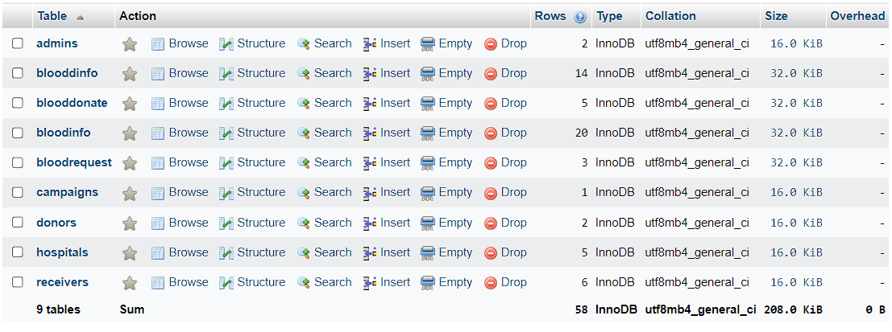

The Fig 5.12 shows the admins table

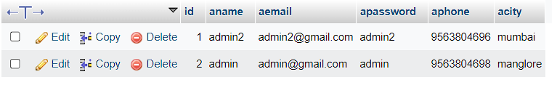

The Fig 5.13 shows the blooddonate table

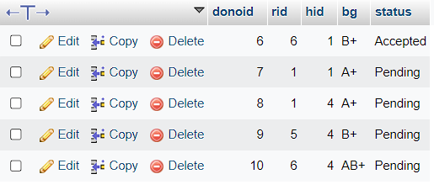

The Fig 5.14 shows the bloodinfo table

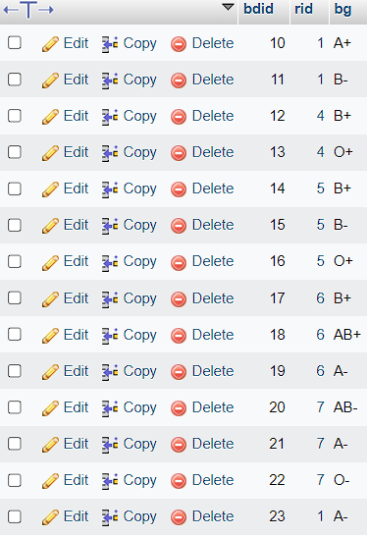

The Fig 5.15 shows the bloodrequest table

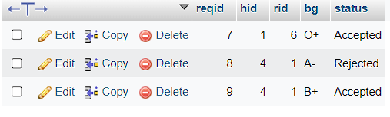

The Fig 5.16 shows the hospital table

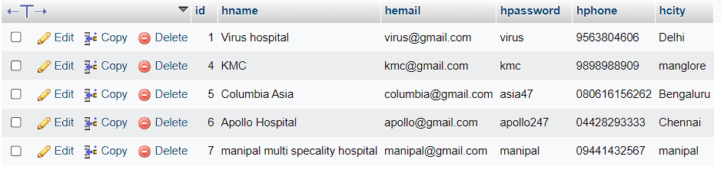

The Fig 5.17 shows the campaigns table

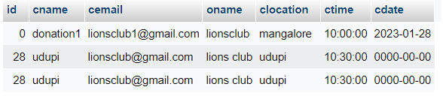

The Fig 5.18 shows the donors table

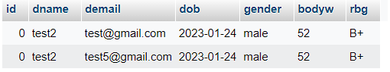

The Fig 5.19 shows the receivers table

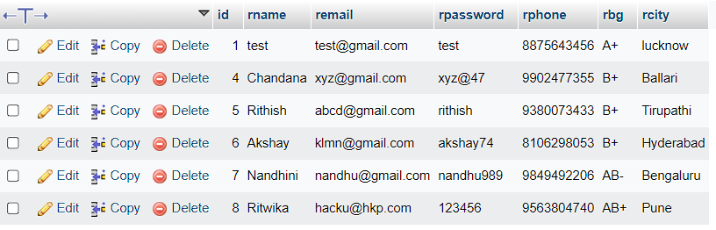

The Fig 5.20 shows the blooddinfo table

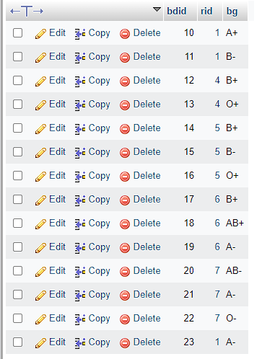

**Front-End Screenshots**

This is the representation of how our front-end looks like when someone uses this project.

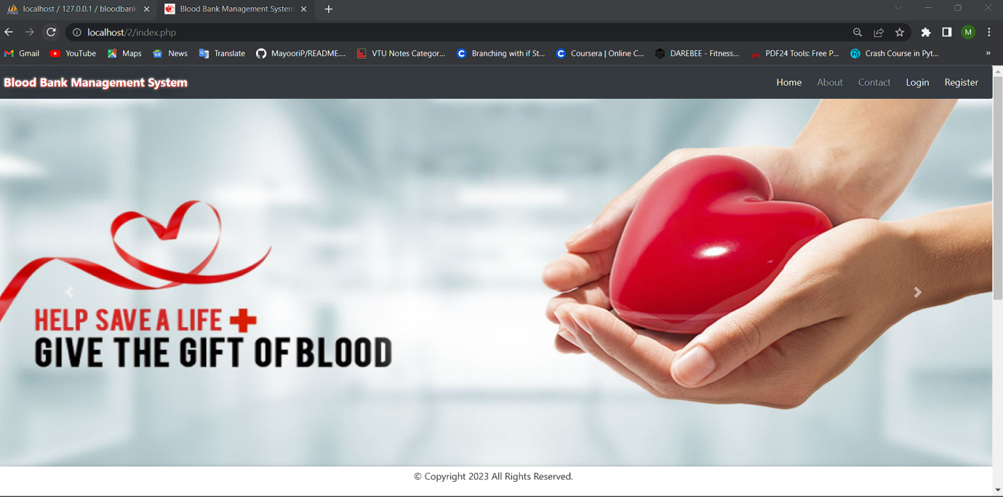

**Fig. 5.11: Home Page**

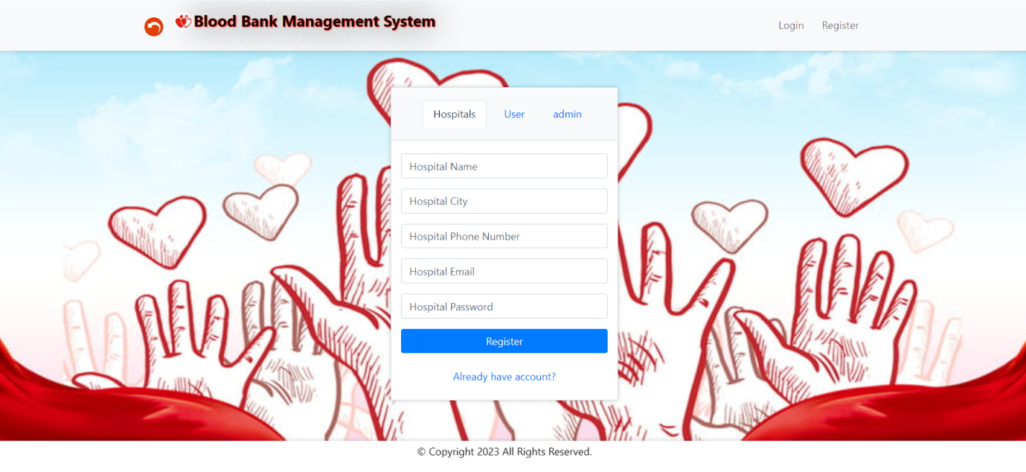

**Fig. 5.12: Hospital register Page**

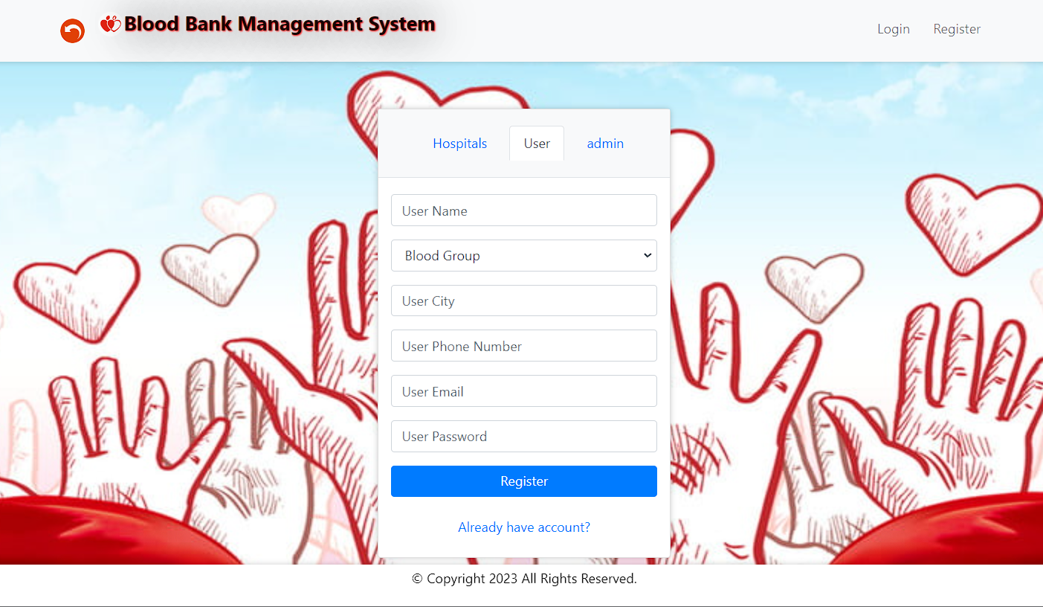

**Fig. 5.13: User register Page**

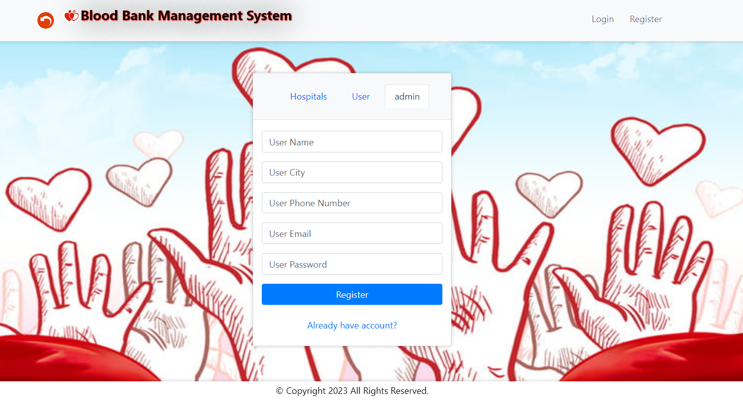

**Fig. 5.14: Admin register Page**

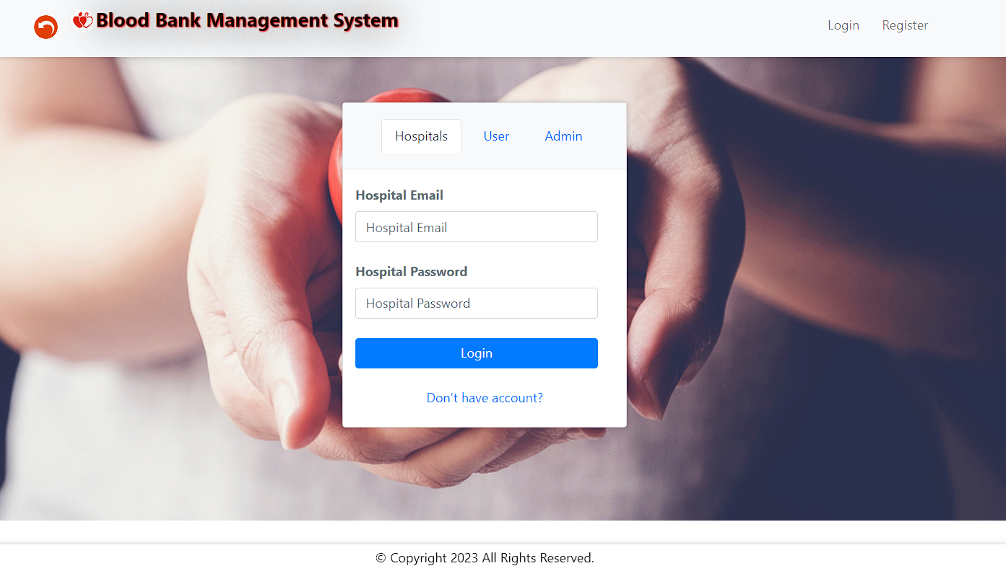

**Fig. 5.15: Hospital login Page**

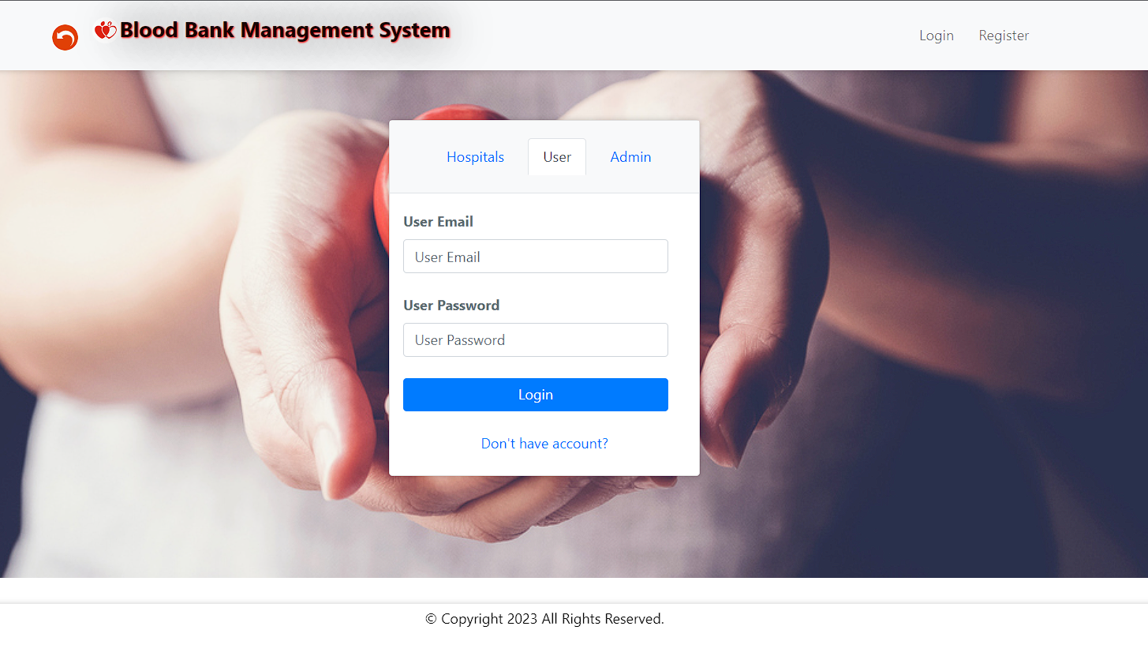

**Fig. 5.16: User login Page**

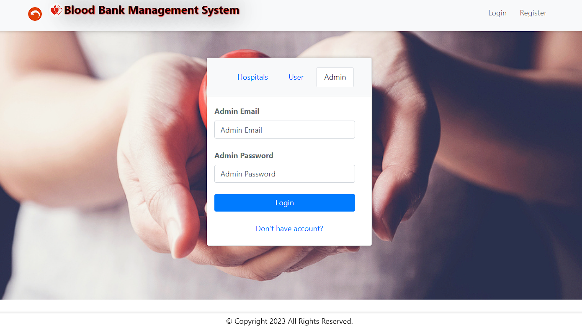

**Fig. 5.17: Admin login Page**

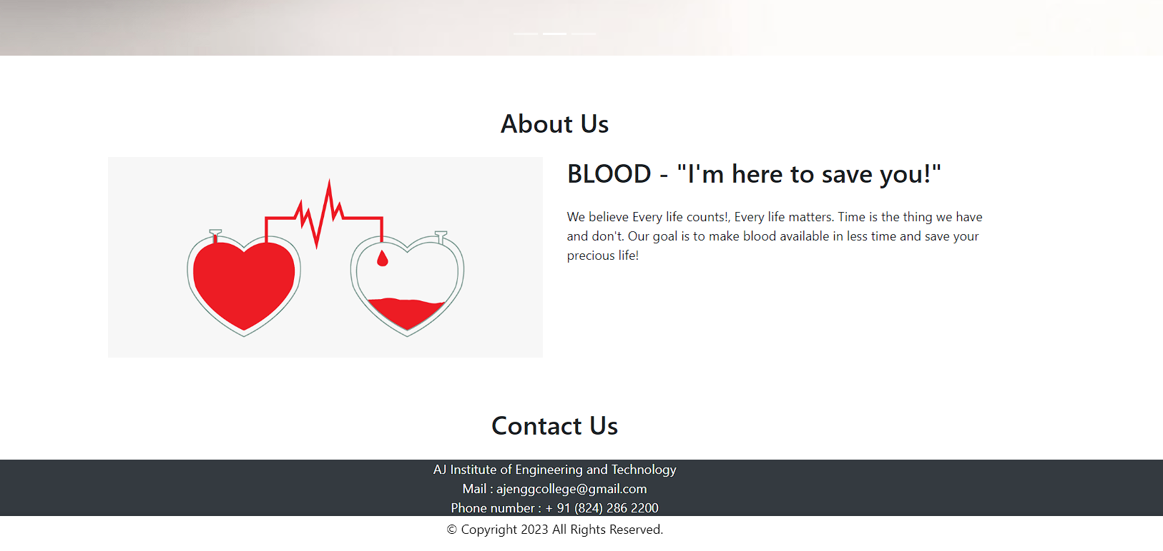

**Fig. 5.18: About Us and Contact Us Page**

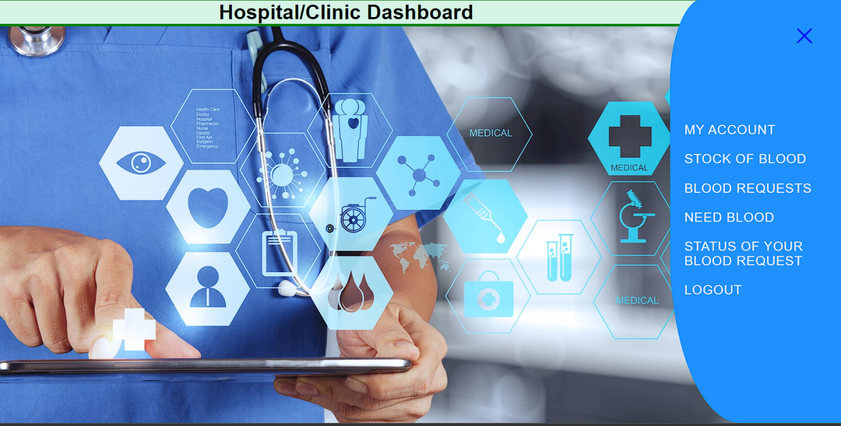

**Fig. 5.19: Hospital Dashboard**

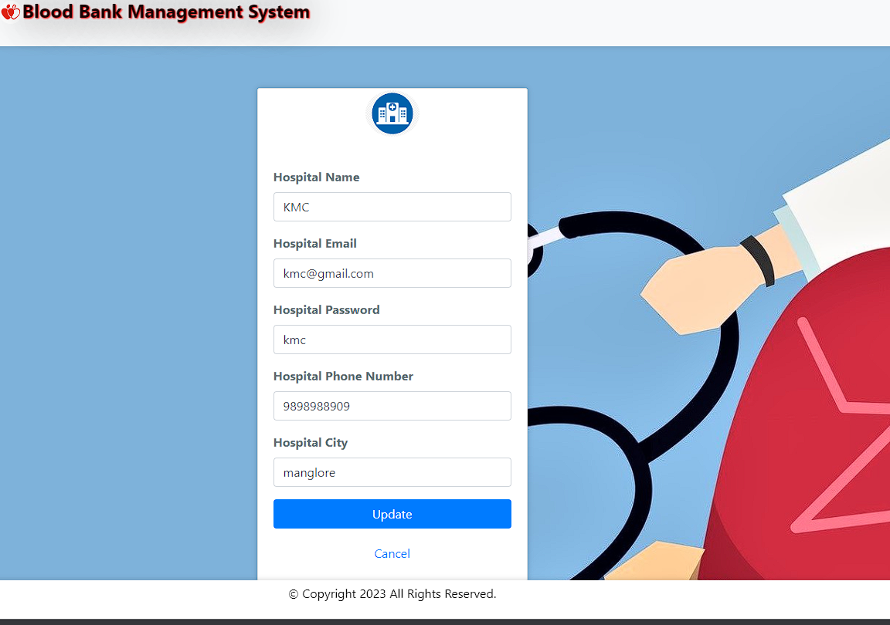

**Fig. 5.20: Hospital Account details**

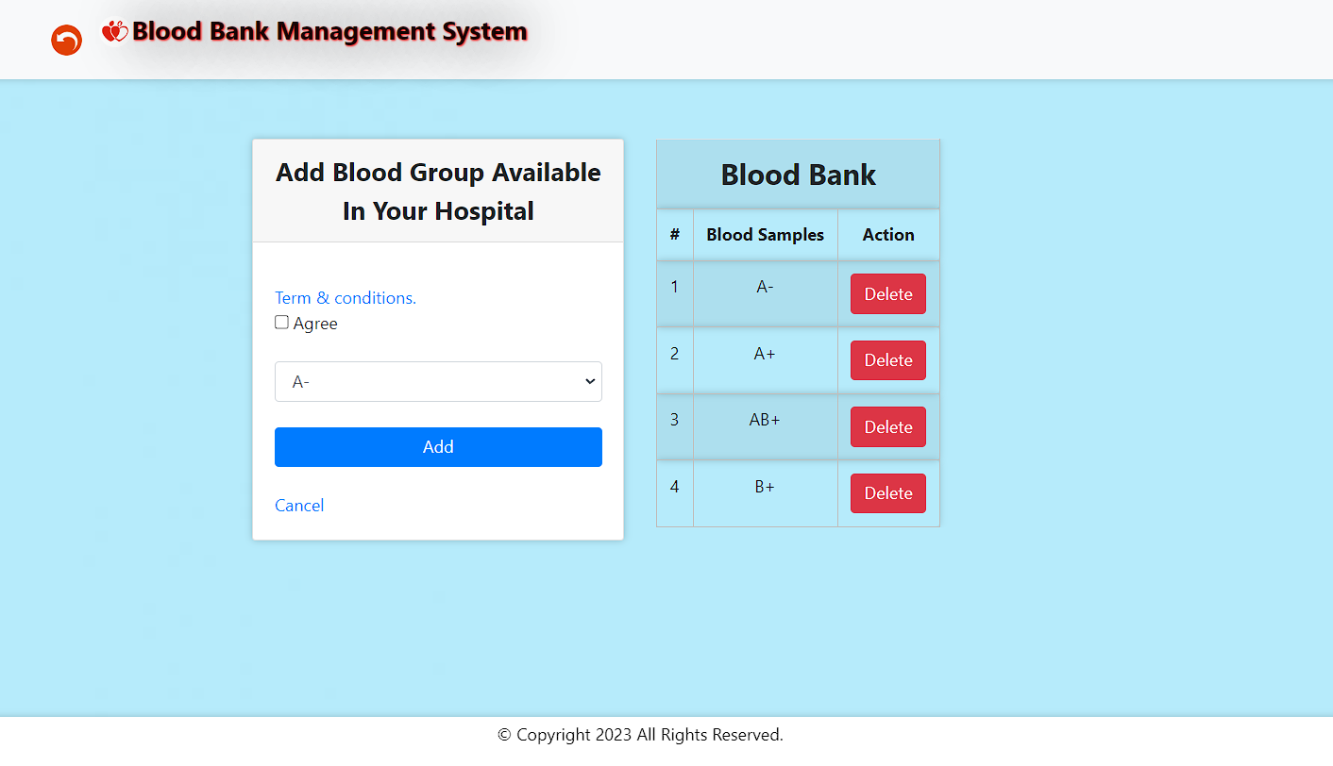

**Fig. 5.21: Hospital stock entry**

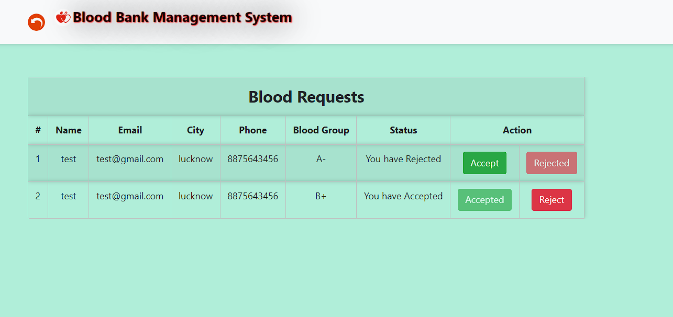

**Fig. 5.22: Hospital Blood request Approval**

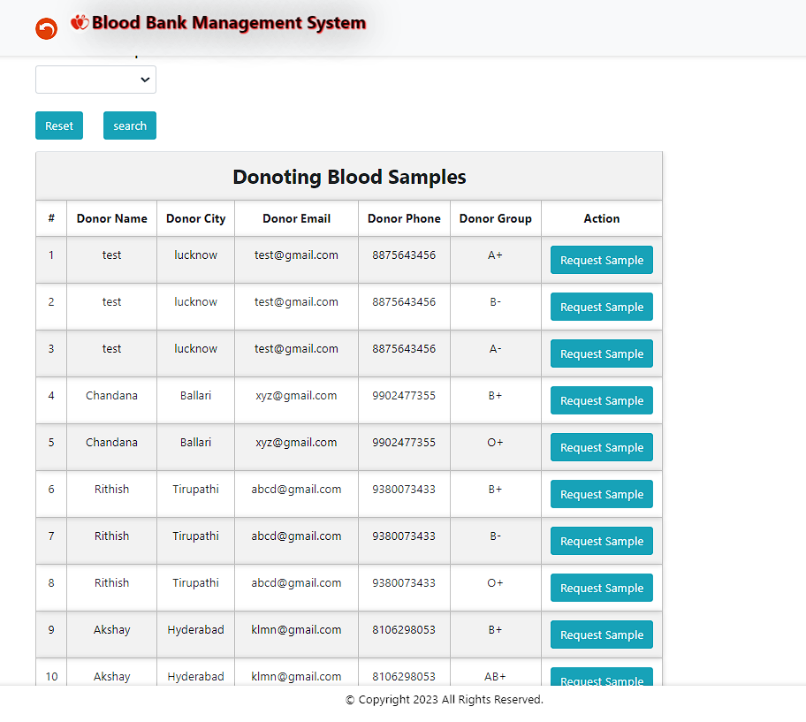

**Fig. 5.23: Hospital Blood request**

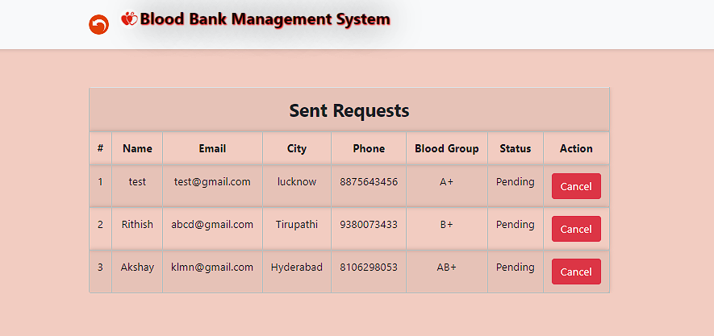

**Fig. 5.24: Hospital Blood request Status**

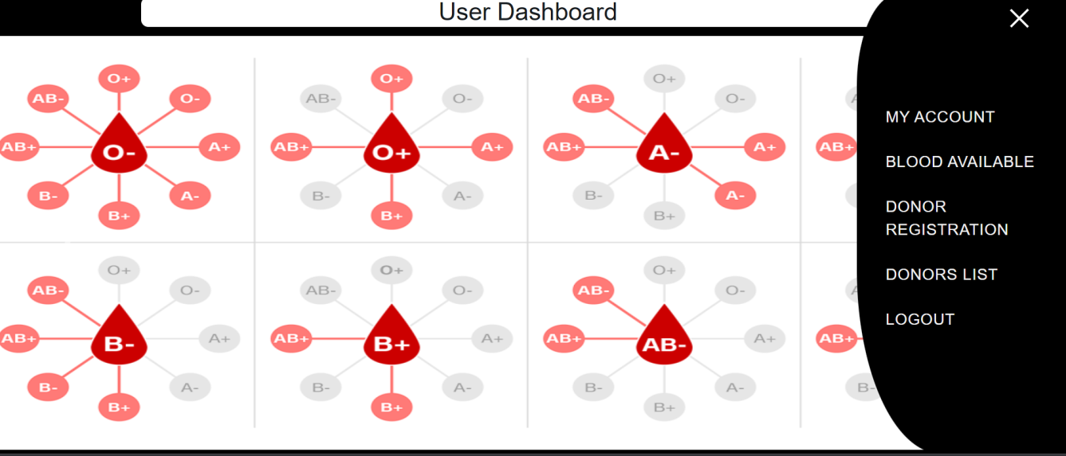

**Fig. 5.25: User dashboard**

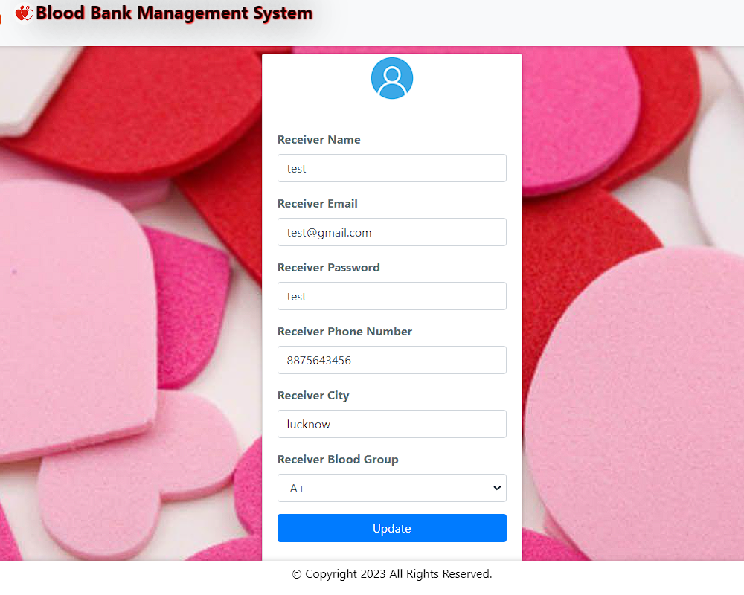**Fig. 5.26: My Account for User**

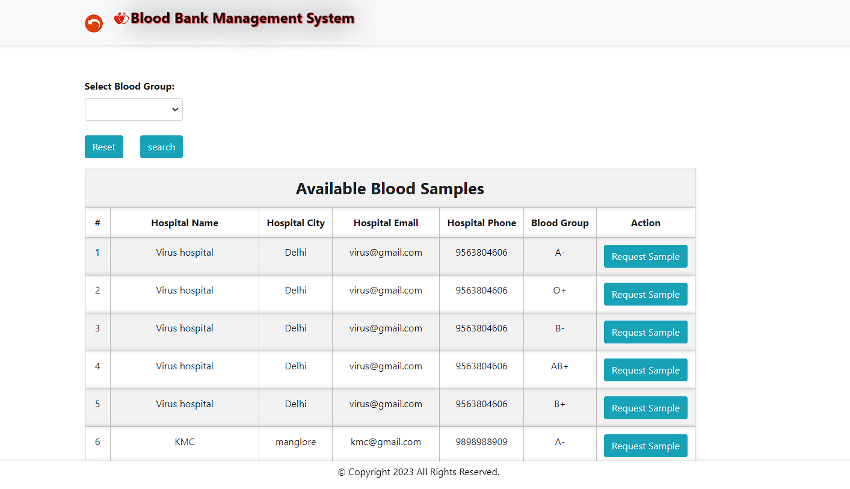

**Fig. 5.27: Available blood for the User**

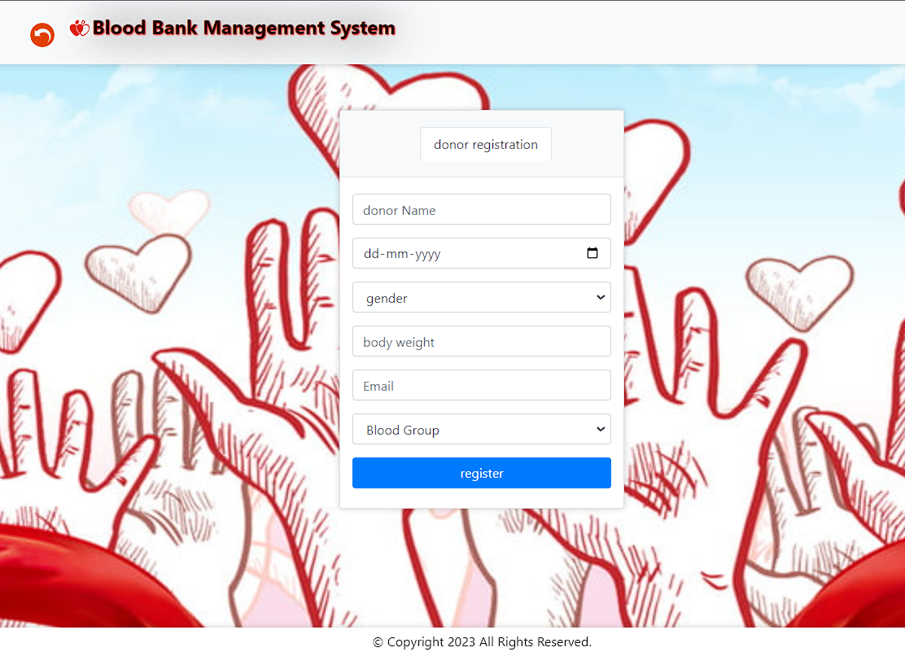

**Fig. 5.28: Donor Registration**

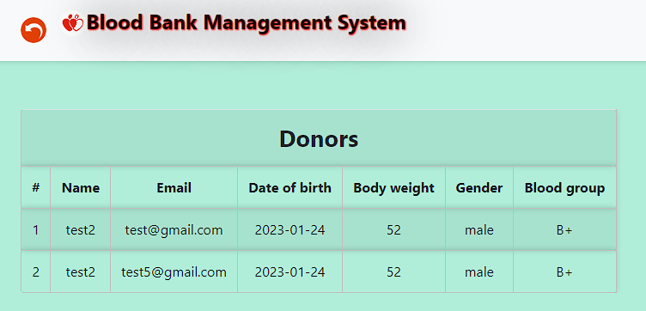

**Fig. 5.29: Blood available for Users**

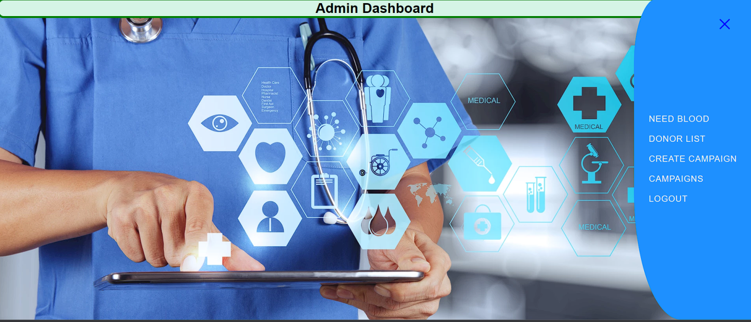

**Fig. 5.30: Admin Dashboard**

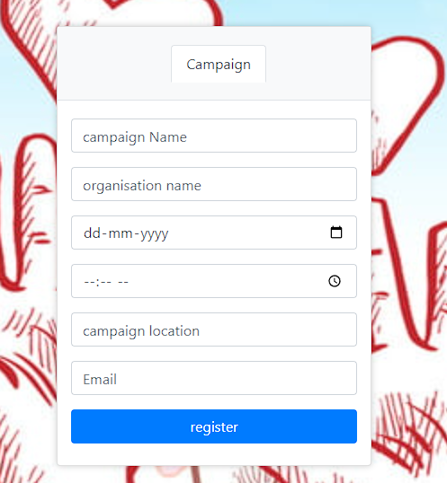

**Fig. 5.31: Campaign register**

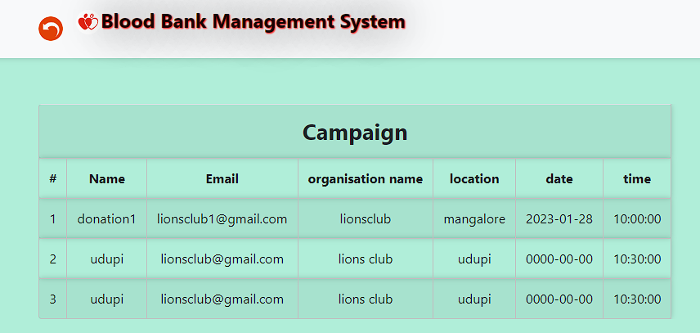

**Fig. 5.32: Campaigns registered**

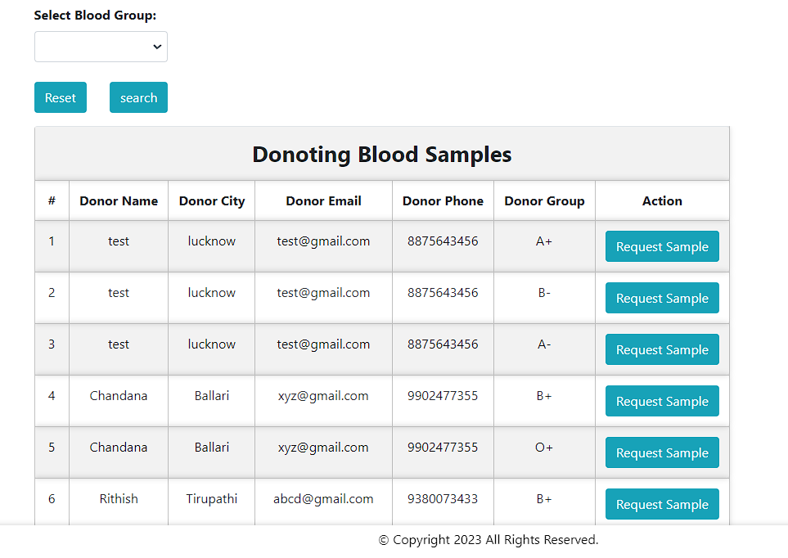

**Fig. 5.33: Available blood stocks**

**CHAPTER 6**

**CONCLUSION AND FUTURE WORK**

**6.1 Conclusion**

The development of Blood bank management system involved many phases. The approach used is a top-down one concentrating on what first and steps for moving to successive levels of details. In primary phase, the system is designed at block level. The blocks are created on the basis of analysis done during the problem identification phase. Different blocks are created for different functions emphasis is put on minimizing the information flow between blocks.

**6.2 Future Work**

As a part of future enhancement,

* We can add the more information on the blood donors.
* Android application can be made so that all type of users can access the page.
* Further add the details of the campaigns.

**REFERENCES**

1. [https://www.w3schools.com/Css/](http://www.w3schools.com/Css/)
2. [https://www.geeksforgeeks.org/php-tutorials/](http://www.geeksforgeeks.org/php-tutorials/)
3. https://www.tutorialspoint.com/
4. Ramez Elmasri and Shamkanth B Navathe “Database System Models language, Design and application program” – Pearson, 7th Edition, 2017
5. HTML & CSS: The Complete Reference, Fifth Edition (Complete Reference Series) by Thomas A. Powell.
6. K.Torp, C.S. Jensen, M.H. Bohlen, “Layered temporal DBMS : Concepts and techniques”, DASFA, pp.371-380, 1997.